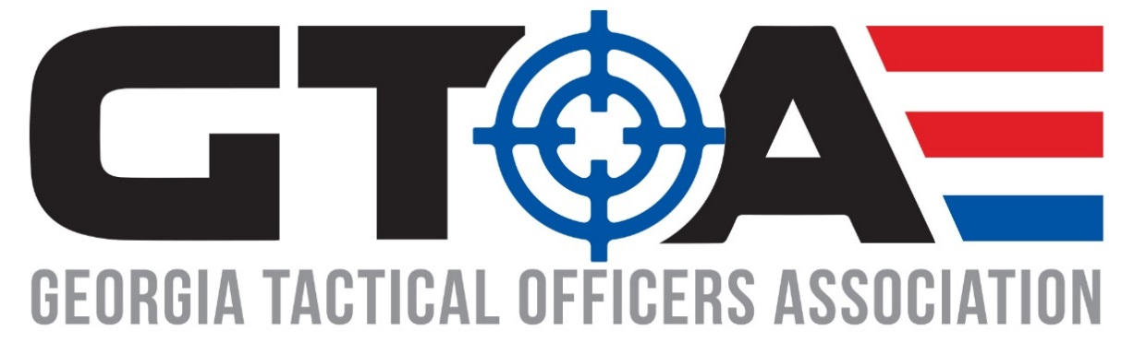
Vendor Conference
March 12th 2019

Platinum Conference Sponsor ( 1 sponsor only) ($7500)
*4 tickets to all GTOA events
*Listed as conference dinner sponsor
*Social media mentions on GTOA Facebook page with sponsor FB tagged/linked.
*2 tables at conference at front entrance premium location
*Full page ad in conference brochure
*Logo on front cover of conference brochure
*Range day slot and acknowledgement in conference brochure
*Conference sponsor may present awards and prizes at conference dinner and recognized by GTOA president.

Diamond Sponsor ($5000)
*2 tickets to all GTOA events
*Listed as sponsor for Range breakfast, and range lunch.
*Social media mentions on GTOA Facebook page with sponsor FB tagged/linked.
*2 tables at Conference at front entrance premium location
*Half page ad in conference brochure
*Range day slot and acknowledgement in conference brochure
*3-5 minute products presentation at Conference awards dinner

Gold Plus Sponsor ($2,500)
*2 tickets to all GTOA events
*Listed as Sponsor for Range breakfast and lunch
*Social media mentions on GTOA Facebook page with sponsor FB tagged/linked.
*2 tables at conference
*Quarter page ad in conference brochure
*Range day slot and acknowledgement in conference brochure
*2 minute presentation during lunch on vendor day

Gold Sponsor ($1,000)
*2 tickets to all GTOA events
*Social media mentions on GTOA Facebook page with sponsor FB tagged/linked.
*1 table at conference
*Quarter page ad in conference brochure
*Range day slot and acknowledgement in conference brochure
*2 minute presentation during lunch on vendor day

Conference Sponsor ($500)
*One table at conference
*Name in conference brochure

Range Day Attendance ($150)
Range day attendance acknowledgment in Conference brochure.

Conference Credit Memo Payment
In lieu of monetary payments to GTOA vendors have a new option for 2019 conference that will allow you to write a credit memo to either Smyrna Police Distributors of Gulf States Distributors for an amount 20% above the conference sponsorship level you are choosing.
Example: Vendor chooses Gold Sponsorship level for $1000, they now write a credit memo to one of the above distributors for $1200.
If you are choosing this option simply e-mail a copy of the credit memo to the distributor of your choice and copy Jomo Bent (jomobent@gmail.com) and Cory Rath (crath@dunkinlewis.com) on the e-mail with your chosen sponsorship level.
Platinum Conference Sponsor $9000 credit memo.
Diamond Sponsor $6200 credit memo.
Gold Sponsor $1200 credit memo.
Conference Sponsor $600.
Conference Sponsor with range $780.

*Upon registration for Gold Level and above, please send company logo for social media posting.

